Name:_______________ Hr:___

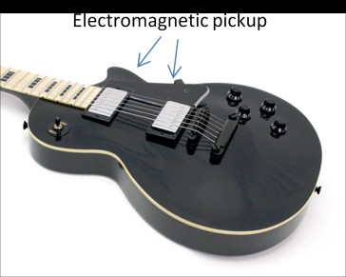**PHYSICS ON THE ELECTRIC GUITAR**

**A. Identify the North and South poles on the black ceramic disk magnet**

**Materials:** black ceramic disk magnet, baggie with iron filings, compass

**Procedures:**

First, check and see if the compass points geographically North.

Use the compass to detect the location of N and S poles on a ceramic disk magnet.

***Keep the iron filings sealed in the baggie***! Lay the baggie flat on the table and spread iron filings out in the baggie. Lay the disk magnet on (not in) the baggie, then fold the baggie over the magnet to see the 3-D magnetic field pattern produced by the disk magnet.

What is the geometric orientation of the magnetic poles on the disk magnet? Label the N and S poles that you determined on the magnet and sketch the pattern of the magnet field lines.

**B. Observe the Interaction between a magnet and a guitar string.**

Materials: black ceramic disk magnet, segment of guitar string, compass, baggie with iron filings

Procedures:

Lay one end of the piece of guitar string from the kit on top of one of the small disk magnets and let it lay there for a few seconds.

Is the string made of a ferromagnetic material?

Where will the North and South poles on the string be located when it is magnetized in this arrangement? Label the North and South poles on the string below. See if you can verify this with the compass.

Sketch the pattern of the magnetic field lines of the magnetized guitar string above.

If the end of the magnetized string was vibrating, as it would be if it was plucked, and a conductor (wire) was near the string, would the conductor be experiencing a changing magnetic field?

Is it possible that the string will become temporarily magnetized if it is near the magnet rather than touching it, as shown?

**C. Using an Amplifier**

Materials: solenoid, two single wires with alligator clips, one alligator clips with mono-plug wire, black cord with one mono-plug and one bi-plug, silver cylinder magnet, Galvanometer, Amplifier

Attach the alligator clips of the two single wires to each of the wire ends of the solenoid, and the other two ends to the terminals of the Galvanometer (measures small amounts of current).



Run the silver cylinder magnet through the center of the solenoid. What is going on and why?



Remove the single wires from the solenoid and attach the alligator clips with the mono-plug wire to the solenoid. Insert the mono-plug into the **INPUT** of the amplifier. Insert the mono-plug end (has only one stripe) of the black cord into the **EXT SPKR** of the amplifier. There still should be two alligator clip wires connected to the Galvanometer. Take the two loose alligator clips and clip them to the bi-plug end of the black cord as illustrated. Turn on the amplifier, and scroll the wheel to half power (NOT full power). Run the silver cylinder magnet through the center of the solenoid.



What does the amplifier do? What would happen if you didn’t have the amplifier?

Unplug the black cord from the EXT SPKR on the amplifier, and turn the amplifier to full power. Run the silver cylinder magnet through the center of the solenoid. Describe what is happening? Remember this for **Part E**.

**D. Putting it all together: Using the pickups Physics Guitar**

Materials: wooden tongue depressor with pick-up, alligator clips with mono-plug, mini-amplifier, simple physics guitar

Procedures:

Attach two alligator clips to the wire ends of the pick-up on the wooden tongue depressor, and then plug the mono-plug into the **INPUT** of the amplifier-speaker.

Turn the amplifier-speaker to the on position and turn the volume knob to maximum.

Slide the “pick-up stick” magnet under one of the strings in the middle. Make sure the magnet does not touch the string.

Pluck the string. Slide the magnet in and out from under the string while it is vibrating and observe what happens.



N

S

On the diagram of the pickup coil, draw the magnetic field lines of the magnet inside the coil.

What is happening to the guitar string when the magnet is below it?

What happens when the guitar string vibrates up and down when the magnet is below it? Hint: think electromagnetically, rather than musically or physically.

The magnet inside the pickup coil is NOT moving, so what is causing the induced current in the wire coil in the pickup?

Why won’t nylon guitar strings work on an electric guitar?

**E. Talking back to the speaker**

In this activity you will identify the parts of a common loud speaker (driver) and consider how it works relative to the force created by the interactions between magnets and coils of current-carrying wire.

Materials: Mini amplifier-speaker, alligator clips to mono-plug cable, small loudspeaker

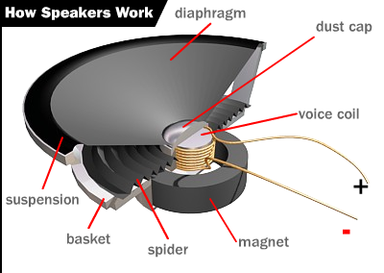Procedures:

Study the illustration to the right and find the components we have discussed to this point: the coil and the magnet.

Connect the mini-amplifier to the small speaker using the mono-to-alligator adapter. VERY GENTLY tap the loud speaker and observe the effect.

Using the same set-up, talk into the loud speaker as if it were a microphone.

Describe the electromagnetic process of talking into the speaker causing the diaphragm and voice coil to vibrate to the point where sound is coming from the amplifier-speaker.

**F. Making a speaker**

Materials: solenoid, alligator clips with mono-plug wire, silver cylinder magnet, cup, disk magnet, cell phone or MP3 player or radio



Procedures:

Insert the mono-plug into the headphone port on your device. Clip the alligator clips to the wires on the solenoid. Put silver magnet in solenoid. Drop the black magnet into the cup and allow the two magnets to pinch the bottom of the cup.

How did this produce sound waves?

